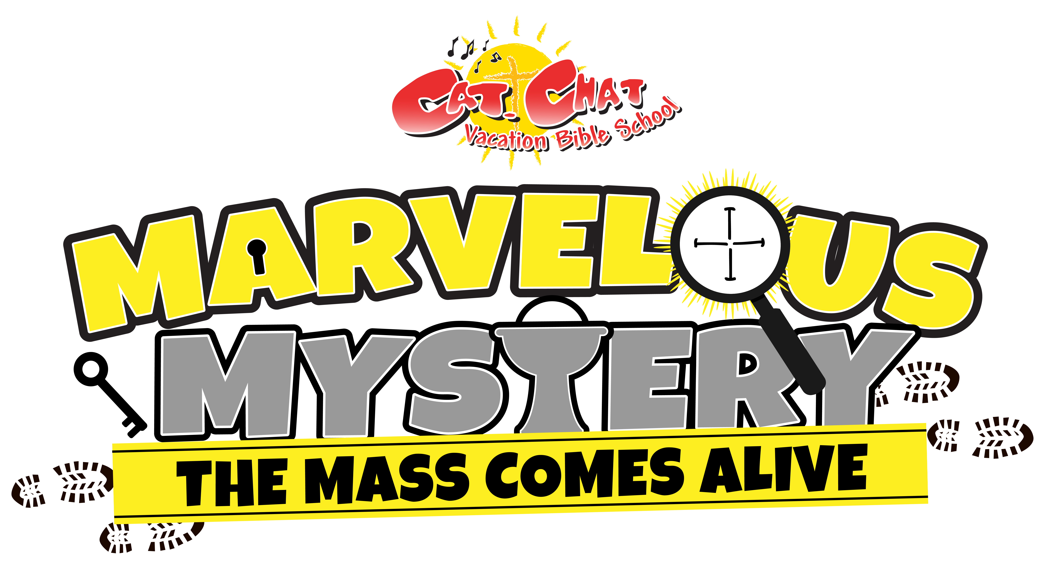

Letter to Parents – Confirming Registration
- - - - - - - - - - - - - - - - - - - - - - - - - - - - - - - - - - - - - - - - - - - - - - - - - - - - - - - - - - - - - - - - - - - -
Dear Parents,

Hello from St. Theresa Vacation Bible School Team!

We are so excited to have your child participate in this year’s Cat.Chat Vacation Bible School:
Marvelous Mystery: The Mass Comes Alive. During this mystery themed VBS, the kids will be exploring the Mass and deepening their love for Jesus in the Eucharist.

We want this to be a whole family experience and so we invite you to attend any of our VBS days.

Start date: We begin on Monday, July 17th at 9:00 am and St. Theresa Parish Hall.

Drop off 8:45 a.m.: We ask that a parent or guardian sign your child in each day at the sign-in tables located in the main entry. Take your child to the main hall to their assigned group leader. Please do not leave until their group leader arrives. It is important that your child arrives on time so we can begin our program on schedule.

Pick-up noon: We ask that when you pick your child up, you let the group leader know and sign them out at the sign-out tables. Remember to take home your child’s craft, any other take home items and any parent handouts.

Payments: VBS payments need to be paid on or before June 30^{th.} Make checks payable to
St. Theresa Catholic Church, 209 Third St. P.O. Box 42, Perry, KS 66073 The cost is $35.00/child or $75.00/family

T-shirts: T-shirts will be distributed on the first day of VBS.

Please have your child wear their t-shirt each day. Children will need to wear running shoes.
Bring a hat and water bottle and have your child wear sunscreen.

On the last day of the VBS, Friday July 21st, we will be having a special celebration. We would love to see parents and grandparents attend and participate with the children. We will end the week with a Marvelous Mystery Party Picnic. Let us know if you can join us for the closing celebration.

May God bless you and your family,

Susan Keehn Director of VBS (785)597-5633
Kimberly Alshahri Assist. Director of VBS (913)535-3018

St. Theresa Catholic Church Vacation Bible School Team

