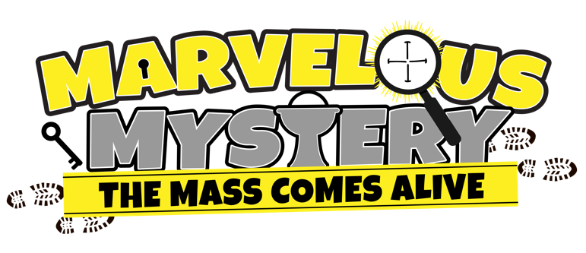

St.Theresa Church is planning a
Vacation Bible School program
this summer for kids ages 4-12.

Join the VBS Team!

If you are interested in helping our kids learn their Catholic faith in a fun and exciting way, please return the completed form to Susan Keehn or Kimberly Alshahri by June 1st.

The theme is Marvelous Mystery: The Mass Comes Alive

----------------------------------------------------------------------------------------------------------------------------------

❑ Yes! I want to help kids learn more about the Mass!

I am interested in helping with: (please check as many as interest you)

 Faith Lessons  Music  Crafts  Snacks
 Games  Group Leader  Decorating  Welcome Committee
 Registration  Skits  Photo/Video  Computer Support

 Child Care  Other: ________________________

Name: ________________________________________________________________________

Address: ______________________________________________________________________

Cell: _________________________________________________________________

Email: ________________________________________________________________________

T-shirt size: (circle one) adult sizes: S M L XL

